Profile of the

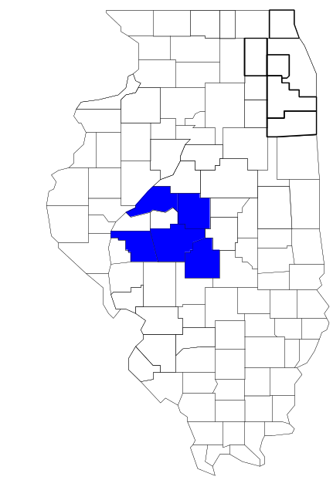Central Illinois Enforcement Group

Prepared by

The Research and Analysis Unit of the
Illinois Criminal Justice Information Authority

George H. Ryan, Governor
Peter B. Bensinger, Chairman
Candice M. Kane, Executive Director

March 2001



ILLINOIS
CRIMINAL JUSTICE
INFORMATION AUTHORITY

This project was supported by Grant # 99-DB-BX-0017, awarded to the Illinois Criminal Justice Information Authority by the Bureau of Justice Assistance, Office of Justice Programs, U.S. Department of Justice. The Assistant Attorney General, Office of Justice Programs, coordinates the activities of the following programs, offices and bureaus: Bureau of Justice Assistance, Bureau of Justice Statistics, National Institute of Justice, Office of Juvenile Justice and Delinquency Prevention, and the Office for Victims of Crime. Points of view or opinions contained within this document are those of the authors and do not necessarily represent the official position or policies of the U.S. Department of Justice.

Illinois Criminal Justice Information Authority
120 S. Riverside Plaza, Suite 1016
Chicago, Illinois 60606-3997
Telephone (312) 793-8550
Telefax (312) 793-8422
TDD: (312) 793-4170
World Wide Website http://www.icjia.state.il.us
ACKNOWLEDGMENTS

A number of organizations and individuals put a great deal of effort into the development of this document. The Authority’s Research and Analysis Unit is very grateful for the assistance provided by the following organizations:

Administrative Office of the Illinois Courts
Illinois Department of Human Services’ Office of Alcoholism and Substance Abuse
Illinois Department of Children and Family Services
Illinois Department of Corrections
Illinois State Police
Central Illinois Enforcement Group
U.S. Bureau of the Census

In addition, the following individuals were instrumental in gathering, interpreting and presenting these data:

Sharyn Adams

Megan Alderden

Robert Bauer

Alissa Clark

John Condne

Karen Griffiths

Tracy Hahn

Jennifer Hiselman

David Katz

Joseph Kozenczak

Gary Kupsak

Erica Morrow

David Olson

Adrianna Perez

Gerard Ramker

Robert Taylor

CONTENTS

Section Page Number

EXECUTIVE SUMMARY

I. Introduction 1
II. Trends in Violent Index Offenses and Arrests 3
III. Trends in Drug Arrests 6
IV. Trends in Drug Seizures 14
V. Trends in Prosecutions for Drug Offenses 16
VI. Trends in Percent of Convicted Drug Offenders Sentenced to Prison 18
VII. Trends in Drug Treatment Admissions in CIEG Region by Drug Type 23
VIII. Trends in Drug Exposed Births 26
IX. Summary of Drug Situation 27
X. Appendices 29
Map 1 1999 Percent of Illinois' County-level Population Covered by an
Authority-funded Multi-jurisdictional Enforcement Group or Task Force 30
Map 2 1999 Illinois Cannabis Seizure Rates, by County 31
Map 3 1999 Illinois Controlled Substances Seizure Rates, by County 32
Map 4 1999 Illinois Methamphetamine Seizure Rates, by County 33
XI. Bibliography 34

LIST OF FIGURES

Figure Page Number

Figure 1. Violent Index Offense Rates for Participating and Non-participating Agencies in Region Covered by CIEG 3
Figure 2. 1999 Violent Index Offenses* Reported by Participating and Non-participating Agencies in Region Covered by CIEG 4
Figure 3. Violent Index Arrest Rates for Participating and Non-participating Agencies in Region Covered by CIEG 5
Figure 4. 1999 Violent Index Arrests* Reported by Participating and Non-participating Agencies in Region Covered by CIEG 5
Figure 5. Total Drug Arrest Rates for CIEG and Participating and Non-participating Agencies in Region Covered by CIEG 7
Figure 6. 1999 Drug Arrests* Reported by Participating and Non-participating Agencies in Region Covered by CIEG 7
Figure 7. Total 1999 Drug Arrests* Reported by Participating and Non-participating Agencies in Region Covered by CIEG, by Drug Type 8
Figure 8. Drug Arrests by CIEG 9
Figure 9. Percent of Total Drug Arrests Accounted for by CIEG 9
Figure 10. Cannabis Arrests Rates in the Region Covered by CIEG as Reported by Participating Agencies, Non-participating Agencies and CIEG 10
Figure 11. Percent of Cannabis Arrests Accounted for by CIEG
11
Figure 12. Controlled Substances Arrest Rates in the Region Covered by CIEG as Reported by Participating Agencies, Non-participating Agencies and CIEG 12
Figure 13. Percent of Controlled Substances Arrests Accounted for by CIEG 12
Figure 14. CIEG Drug Arrests for Possession versus Delivery, by Drug Type 13
Figure 15. Cannabis Seized and Submitted to ISP by Christian, Logan, Mason, Morgan and Sangamon Counties and Seized by CIEG 14
Figure 16. Powder and Crack Cocaine Seized and Submitted to ISP by Christian, Logan, Mason, Morgan and Sangamon counties and Seized by CIEG 15
Figure 17. Number of Felony Filings in Christian, Logan, Mason, Morgan and Sangamon Counties 16
Figure 18. Total CIEG Drug Arrests and Percentage of Arrests Resulting in Prosecution 17
Figure 19. Sentences Imposed on Felons Convicted in Christian, Logan, Mason, Morgan and Sangamon Counties
18
Figure 20. Sentences Imposed on Convicted CIEG Drug Offenders 19
Figure 21. Number of Drug Offenders Committed to IDOC by CIEG and Region Covered by CIEG 20
Figure 22. Drug Offenders as a Percent of Total IDOC Commitments from Christian, Logan, Mason, Morgan and Sangamon counties 21
Figure 23. Drug Offenders Committed to IDOC from Christian, Logan, Mason, Morgan and Sangamon Counties, by Offense Class 22
Figure 24. Substance Abuse Treatment Admissions from Christian, Logan, Mason, Morgan and Sangamon Counties 23
Figure 25. Comparison of Drug Arrests by CIEG and Participating and Non-participating Agencies vs. Drug Abuse Treatment Admissions in Christian, Logan, Mason, Morgan and Sangamon Counties 25
Figure 26. Cases of Drug-Exposed Infants in Christian, Logan, Mason, Morgan and Sangamon Counties 26
Figure 27. Availability of Drugs in Illinois, 1998 27
Figure 28. Price Per Gram in Illinois, 1998 28

EXECUTIVE SUMMARY

Since 1989, the Authority’s Research and Analysis Unit has received funds under the federal Anti-Drug Abuse Act of 1988 to document the extent and nature of drug and violent crime in Illinois and the criminal justice system’s response to these offenses. As a result of these efforts, the Authority has amassed a large amount of data measuring the extent and nature of drug and violent crime in Illinois and the impact these crimes have had on the criminal justice system. In addition, as part of its monitoring and evaluation efforts, the Authority also requires funded programs to submit monthly data reports describing their activities and accomplishments. This profile is intended to provide a general overview of the drug and violent crime problem in the jurisdictions covered by Illinois’ MEGs and task forces, and the response to these problems by the units.

Although the data presented in this report are by no means inclusive of all indicators, they do provide a general overview of drug and violent crime and the response and impact of the criminal justice system. The following represent general conclusions that can be made based on the data analyzed for this report.

- In 1999, 13 local Illinois police agencies participated in CIEG (a participating agency is defined as one that contributes either personnel or financial resources to CIEG). Officers assigned to CIEG (totaling 13 in 1999, 9 from participating agencies) accounted for less than one percent of the total number of sworn police officers working for agencies participating in CIEG.

- The violent Index offense rate was collectively higher across the jurisdictions that participated in CIEG than it was among the combined jurisdictions that did not participate in CIEG (page 3).

- The drug arrest rate tended to be slightly higher in the jurisdictions that participated in CIEG than in those jurisdictions that did not participate in CIEG. Also, the drug arrest rate achieved by CIEG was significantly lower than the rate experienced by both the participating and non-participating agencies, meaning that the unit made one-tenth as many arrests for violations of the Cannabis Control and Controlled Substances Acts, with nine officers, as did all of the participating agencies combined. (page 6).

- When comparing the types of drug offenders arrested by those agencies participating in CIEG, those agencies not participating, and CIEG, it was found that CIEG tended to target and arrest more serious drug law violators, specifically violators of the Controlled Substances Act, which tend to be felony-level offenses (page 8).

- The majority of all drug arrests reported by CIEG, for either violations of the Cannabis Control Act or the Controlled Substances Act, involve drug sale or delivery (page 13).

- Between 1993 and 1999, both the cannabis and cocaine seizures by CIEG increased substantially (pages 14 and 15).

- Between 1991 and 1999, 94 percent of all drug arrests by CIEG resulted in prosecution. Of these CIEG drug offender prosecutions, 63 percent were for violations of the Controlled Substance Act. In addition, between 1989 and 1999, 88 percent of drug offenders who were prosecuted as a result of CIEG activity were convicted (page 17).
- In 1999, among those CIEG drug offenders convicted and sentenced, prison and probation sentences each accounted for 41 percent of total sentences, while jail sentences accounted for 18 percent of drug offenders convicted and sentenced (page 19).

- Between 1989 and 1999, prison sentences resulting from CIEG cases accounted for one-third of all drug-law violators sent to prison from the region where CIEG operates (page 20).

- Unlike the arrests made by participating and non-participating agencies, the arrests made by CIEG tended to involve the substances considered to be most serious (i.e., felony versus misdemeanor) and the substances for which a large proportion of community residents were seeking and receiving substance abuse treatment (page 24).

I. Introduction

The Central Illinois Enforcement Group (CIEG) covers the Illinois counties of Christian, Logan, Mason, Morgan and Sangamon. Combined, these counties had a 1999 total population of 207,062 – 5 percent more than in 1990. In 1999, 13 local police agencies participated in CIEG. These include the Christian, Mason, and Morgan County Sheriff's Offices and the following municipal police departments: Havana, Jacksonville, Jerome, Leland, Lincoln, Meredosia, Pana, Pawnee, Springfield and Taylorville. These agencies served two-thirds of the population in the five-county region covered by CIEG in 1999 (see Map 1 on page 30). A participating agency is defined as one that contributes either personnel or financial resources to CIEG.

In addition to agencies that participate in CIEG, these Illinois counties are served by 38 additional police departments that do not participate in CIEG. According to the Illinois State Police, county sheriffs and local police departments, in the five-county region covered by CIEG, combined, employed 1,044 full-time police officers as of Oct. 31, 1999. In comparison, there were a total of just 13 officers assigned to CIEG in 1999, nine of which were assigned by participating agencies and four from the Illinois State Police. Thus, the officers assigned to CIEG during 1999 accounted for a relatively small proportion—less than 1 percent--of the total number of sworn police officers working in the participating police departments, and the region as a whole.

Since 1989, the Authority’s Research and Analysis Unit has received funds under the federal Anti-Drug Abuse Act of 1988 to document the extent and nature of drug and violent crime in Illinois and the criminal justice system’s response to these offenses. As a result of these efforts, the Authority has amassed a large amount of data measuring the extent and nature of drug and violent crime in Illinois and the impact these crimes have had on the criminal justice system. In addition, as part of its monitoring and evaluation efforts, the Authority also requires funded programs to submit monthly data reports describing their activities and accomplishments. To put this information into the hands of Metropolitan Enforcement Group (MEG) and drug task force directors and policy board members, the Authority’s Research and Analysis Unit has developed profiles – of which this is one – for each MEG and task force. The profile is intended to provide a general overview of the drug and violent crime problem in the jurisdictions covered by Illinois’ MEGs and task forces, and the response to these problems by the units.

In addition to administering federal block-grant funds that come to Illinois for crime control initiatives, the Illinois Criminal Justice Information Authority is also responsible for providing policymakers, criminal justice professionals and others with information, tools and technology needed to make effective decisions that improve the quality of criminal justice in Illinois. The Authority provides an objective system-wide forum for identifying critical problems in criminal justice, developing coordinated and cost-effective strategies, and implementing and evaluating solutions to those problems. The specific powers and duties of the Authority are delineated in the Illinois Criminal Justice Information Act (Illinois Compiled Statutes, Ch. 20, Sec. 3930). Two of the Authority’s many responsibilities are serving as a clearinghouse of information and research on criminal justice and undertaking research studies to improve the administration of criminal justice.

While the data presented in this report are by no means inclusive of all indicators, they do provide a general overview of drug and violent crime and the response and impact of the criminal justice system. In addition, these data are readily available and consistently defined through existing statewide data collection mechanisms. Some data presented in this profile have been analyzed differently than in previous years; therefore, caution must be taken when comparing numbers presented with previous profiles.
While a considerable amount of the information presented in this profile has been provided to the Authority by CIEG, a number of state agencies have also provided data to the Authority that are included in this report. Specifically, the Illinois State Police, the Administrative Office of the Illinois Courts, the Illinois Department of Human Services’ Office of Alcoholism and Substance Abuse, the Illinois Department of Corrections and the Illinois Department of Children and Family Services all provided data used to develop this profile. The support and cooperation of these agencies and their staffs have helped make this report an informative and timely source of information on the activities of the criminal justice system in Illinois.

- Trends in Violent Index Offenses and Arrests

While most of Illinois’ Metropolitan Enforcement Groups and drug task forces are primarily involved in drug enforcement activities, it is clear that the relationship between drugs and violence is particularly evident in a number of Illinois communities. In addition, a number of MEGs and task forces have increased their involvement in the investigation of violent crime, particularly that associated with gang activity and violence related to drug distribution, sale and turf battles. One of the most commonly used indicators of the level of crime in a particular jurisdiction is the number of Index offenses reported to the police. In Illinois, as part of the Illinois Uniform Crime Reporting (I-UCR) program, every law enforcement agency in the state is required to report crime data monthly to the Illinois State Police (ISP). There are eight separate offenses that constitute the Crime Index, including murder, criminal sexual assault, robbery, aggravated assault (violent Index offenses), burglary, theft, motor vehicle theft and arson (property Index offenses). Although these eight offenses do not account for all crimes reported to the police, they are considered to be the most serious, frequent, pervasive and consistently defined by different law enforcement agencies.

In 1999, the total number of violent Index offenses reported to the police in the five-county region where CIEG operates totaled 1,868, an 18 percent decrease from the 2,265 offenses reported in 1993. The majority (69 percent) of violent Index offenses reported to the police between 1993 and 1999 were aggravated assaults, while 22 percent were robberies.

During the period analyzed, the violent Index offense rate for the region covered by CIEG also decreased 18 percent, from 737 offenses per 100,000 population in 1993 to 601 offenses per 100,000 population in 1999. The violent Index offense rate in the participating agencies decreased 26 percent, from 1,020 to 757 offenses per 100,000 population, while the rate in the non-participating agencies increased 50 percent, from 192 to 289 offenses per 100,000 population (Figure 1). Thus, while the violent Index offense rate was collectively higher across the jurisdictions that participate in CIEG than it was among the combined jurisdictions that did not participate in CIEG, the violent Index offense rate has steadily decreased over the past six years in those agencies that participate in CIEG, while increasing in those agencies that do not participate in CIEG.
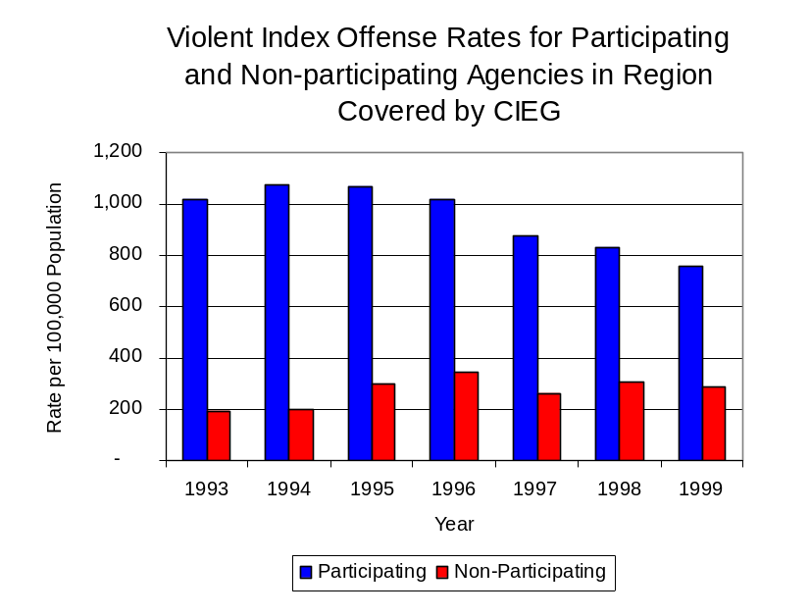
Source: ICJIA calculations using
Illinois State Police and U.S. Census Bureau data
Figure 1
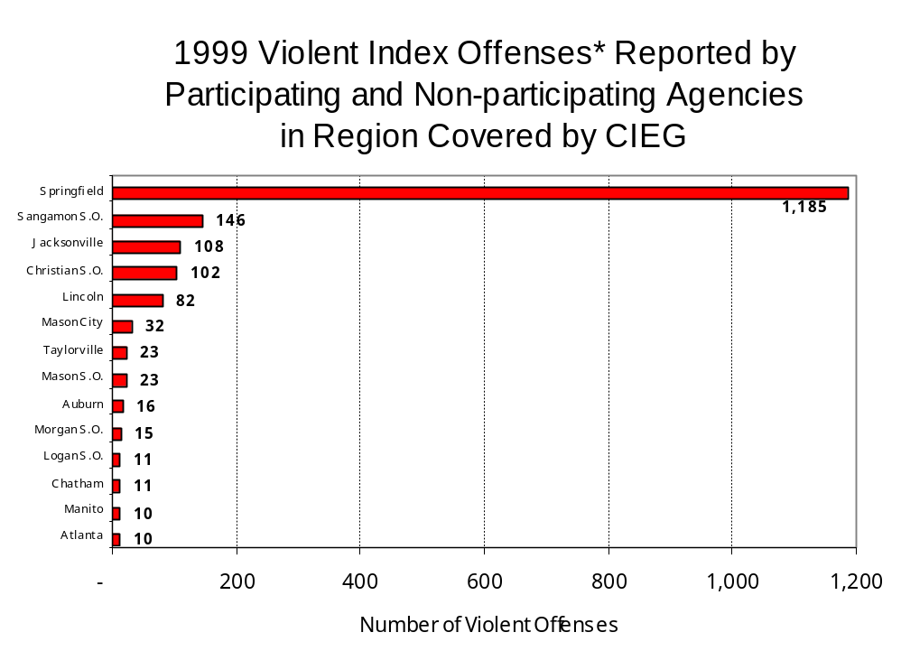
Across the 51 individual local law enforcement agencies covered by CIEG’s jurisdiction, four agencies, the Springfield Police Department, the Sangamon County Sheriff's Office, The Jacksonville Police Department and the Christian County Sheriff's Office accounted for 82 percent of all violent offenses reported to the police (Figure 2). Thirty-seven agencies had fewer than ten violent offenses reported in 1999 and are excluded from Figure 2. When controlling for differences in the populations served by these law enforcement agencies, the violent Index offense rate ranged from 1,274 violent Index offenses per 100,000 population in Mason City to 30 offenses per 100,000 population in South Jacksonville. Seventeen agencies in the five-county region covered by CIEG did not report any violent Index offenses in 1999.
Source: Illinois State Police *Agencies reporting ten or more violent offenses
Figure 2
An indicator of the workload that law enforcement agencies place on other components of the justice system is the number of arrests made by police, including those for violent and property Index offenses and drug offenses. Unlike offenses, which are what police must respond to, arrests represent those offenders who may eventually be processed through other components of the justice system, including the courts, county jails, and state and local correctional programs.

Between 1993 and 1999, the number of arrests for violent Index offenses made by law enforcement agencies in the region covered by CIEG decreased 30 percent, from 1,061 to 745. As with reported violent Index offenses, the majority (79 percent) of violent Index arrests were for aggravated assaults, followed by robberies (11 percent).

During the period analyzed, the violent Index arrest rate for the region covered by CIEG decreased 30 percent, from 354 offenses per 100,000 population in 1993 to 240 arrests per 100,000 population in 1999. Similarly, the violent Index arrest rate in the participating agencies decreased 29 percent, from 402 to 284 offenses per 100,000 population, while the rate in the non-participating agencies decreased 36 percent, from 235 to 150 offenses per 100,000 population (Figure 3).

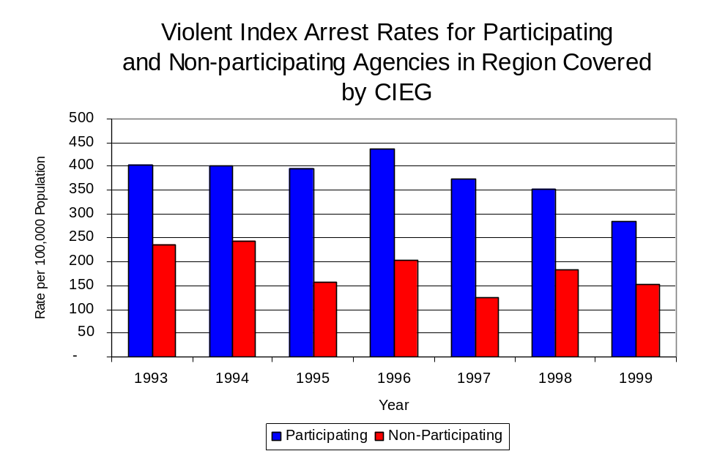
Similar to the number of violent Index offenses, the majority (79 percent) of arrests for violent Index offenses occurring in the five-county region covered by CIEG were made by five agencies. Forty-two agencies had fewer than ten arrests for violent Index offenses reported in 1999 and are excluded from Figure 4. Of the 745 violent Index arrests made in 1999, the Springfield Police Department accounted for the largest proportion (46 percent), followed by the Jacksonville Police Department (11 percent), the Sangamon County Sheriff’s Office (9 percent), the Christian County Sheriff's Office (7 percent) and the Lincoln Police Department (6 percent) (Figure 4).
Figure 3
Source: ICJIA calculations using
Illinois State Police and U. S. Census Bureau data

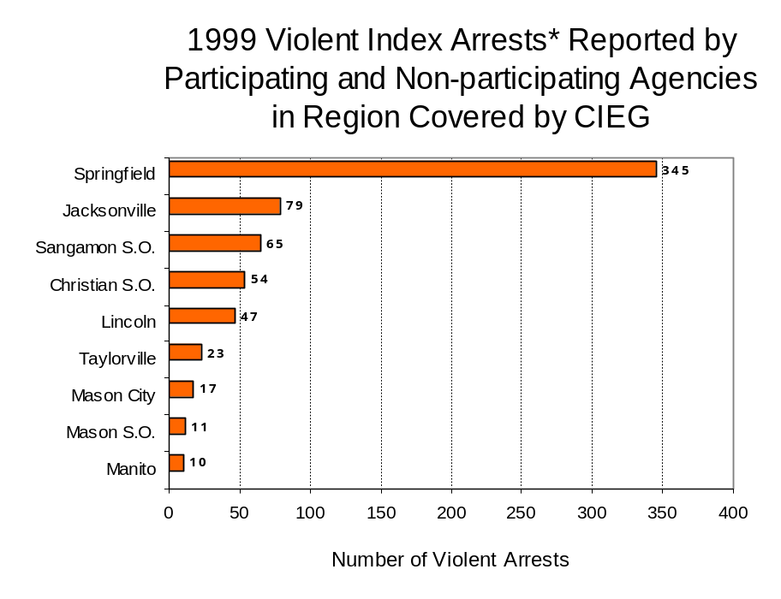
Figure 4
Source: Illinois State Police *Agencies reporting ten or more violent offenses
III. Trends in Drug Arrests

There are two sources of drug arrest data presented in this section. One source is the Illinois Uniform Crime Reporting (I-UCR) program that includes information submitted by local law enforcement agencies on the number of persons arrested for violations of Illinois’ Cannabis Control Act, Controlled Substances Act, Hypodermic Syringes and Needles Act, and Drug Paraphernalia Control Act. In addition, data on drug arrests made by Illinois’ MEGs and task forces are reported to the Illinois Criminal Justice Information Authority. In some jurisdictions, arrests made by the MEG or task force may be reported by both local law enforcement agencies through the I-UCR and to the Authority by the unit. In other jurisdictions, arrests made by the MEG or task force are only reported to the Authority by the unit. Therefore, in some instances drug arrests may be double counted – included in both local agency statistics reported to I-UCR and those of the MEG or task force. Currently there is no mechanism in place to ensure that drug arrest statistics are not being duplicated at both the local agency and MEG/task force level. This should be kept in mind when interpreting the information presented in the following section.

The majority of drug offenses in Illinois are violations of either the Cannabis Control Act – which prohibits the possession, sale and cultivation of marijuana – or the Controlled Substances Act – which prohibits the possession, sale, distribution or manufacture of all other illegal drugs, such as cocaine and opiates. Illinois also has various other laws prohibiting other drug-related activity. These include the Hypodermic Syringes and Needles Act – which prohibits the possession or sale of hypodermic instruments – and the Drug Paraphernalia Control Act – which prohibits the possession, sale or delivery of drug paraphernalia. In general, violations of Illinois Controlled Substances Act are considered to be more serious, since they primarily involve cocaine, heroin, methamphetamine, and hallucinogens, and are almost all classified under Illinois law as felonies. The majority of cannabis and drug paraphernalia offenses encountered by police, on the other hand, tend to be misdemeanor-level offenses.

In 1999, local law enforcement agencies in the counties covered by CIEG reported 1,133 arrests for drug law violations, 43 percent more than the number in 1993 (794 arrests). Between 1993 and 1999, arrests for violations of Illinois’ Cannabis Control Act consistently out-numbered arrests for violations of the Controlled Substances Act during the years analyzed in Christian, Logan, Mason, Morgan and Sangamon counties, combined. During the same period, the number of arrests for violations of the Cannabis Control Act in these five counties combined increased 81 percent, from 423 to 764. Arrests for violations of the Controlled Substances Act in the five-county region combined decreased slightly, from 371 to 369. In addition, arrests for violations of the Drug Paraphernalia Control Act, enacted in 1993, increased dramatically from eight in 1993 to 467 in 1999. Much of this increase can be attributed to a 1994 addition to the Drug Paraphernalia Control Act, which included the possession of drug paraphernalia as a violation.

Because arrests for violations of the Drug Paraphernalia Control Act are frequently made in conjunction with other drug offense arrests, these arrests may be double-counted, thus skewing the actual number of drug arrests. Therefore, only arrests for violations of the Cannabis Control Act and Controlled Substances Act will be used for drug arrest comparisons between CIEG and the participating and non-participating agencies.

During the period analyzed, the drug arrest rate for the Cannabis Control and Controlled Substances Acts, combined, in the region covered by CIEG increased 41 percent, from 258 arrests per 100,000 population in 1993 to 365 arrests per 100,000 population in 1999. Similarly, the drug arrest rate in the participating and non-participating agencies also increased, from 248 to 382 arrests per 100,000 population and 279 to 329 arrests per 100,000 population, respectively. The arrest rate for CIEG, on the other hand, decreased 31 percent, from 53 to 37 arrests per 100,000 population (Figure 5). Thus, the drug arrest rate tended to be slightly higher collectively in the jurisdictions that participated in CIEG than in those jurisdictions that did not participate in CIEG. Also, the drug arrest rate achieved by CIEG was significantly lower than the rate experienced by both the participating and non-participating agencies, meaning that the unit made one-tenth as many arrests for violations of the Cannabis Control and Controlled Substances Acts, with 13 officers, as did all of the participating agencies combined.
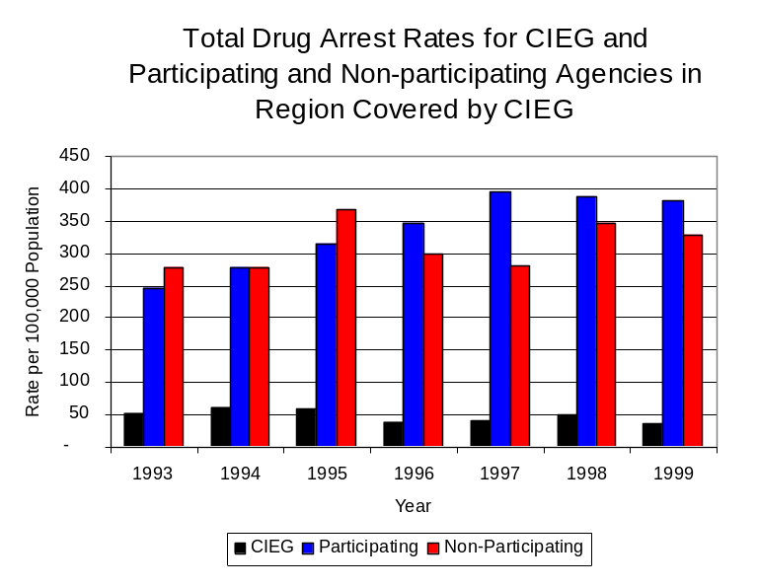
Source: ICJIA calculations using Illinois State Police and U.S. Census Bureau data
Figure 5

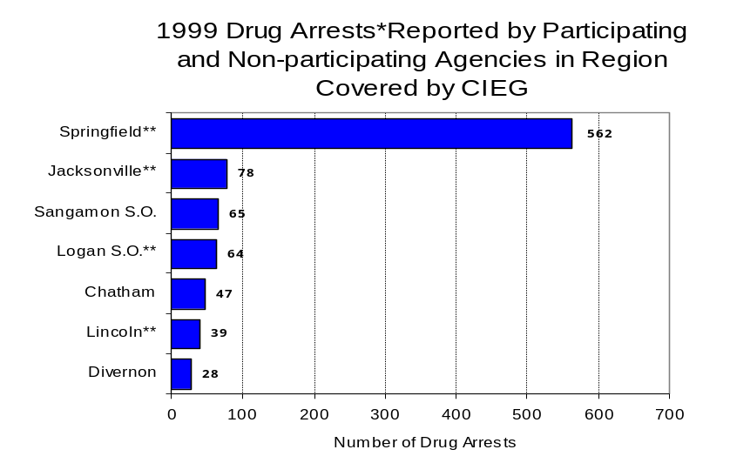
Across the individual local law enforcement agencies in the region covered by CIEG, the number of total cannabis and controlled substances arrests ranged from zero to 1,133. Eighteen agencies reported no drug arrests in 1999. Of the 1,133 drug arrests made during 1999 in the five-county region, seven agencies accounted for 78 percent of these drug arrests. Forty-four agencies had fewer than 25 drug arrests reported in 1999 and are excluded from Figure 6. Springfield accounted for one-half of all drug arrests in Christian, Logan, Mason, Morgan and Sangamon counties, followed by the Jacksonville (7 percent), the Sangamon and Logan County Sheriff’s Offices (6 percent each), Chatham (4 percent), Lincoln (3 percent) and Divernon (2 percent) (Figure 6). Among the seven agencies with the highest number of drug arrests during 1999, four participated in CIEG.
Figure 6
Source: Illinois State Police *Agencies reporting 25 or more drug arrests
**Agencies participating in CIEG

In addition to the dramatic difference in the number of drug arrests made, there are also
differences in the types of drug law violation arrests across the agencies in the region. In 1999, violations of the Cannabis Control Act accounted for the largest proportion of arrests across most individual agencies in the region covered by CIEG (Figure 7).
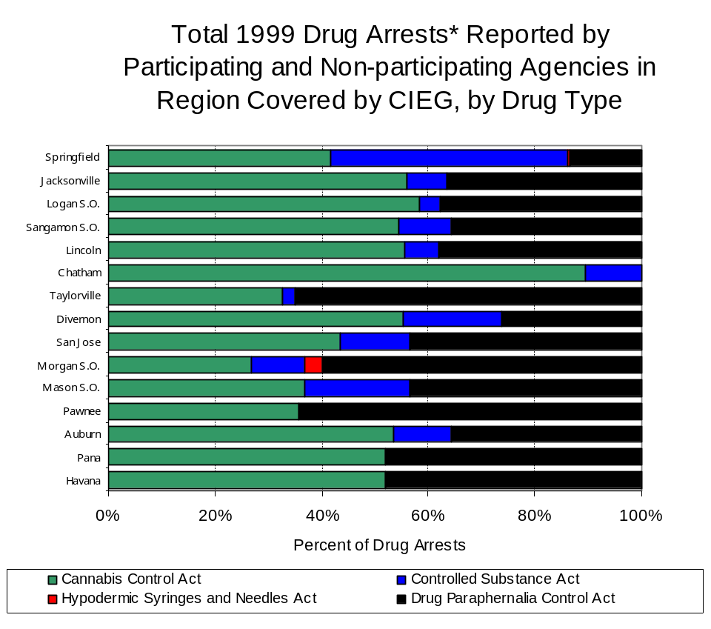
Figure 7
Source: Illinois State Police *Agencies reporting 25 or more drug arrests
Between 1993 and 1999, the number of combined cannabis and controlled substances arrests made by CIEG decreased 29 percent, from 107 to 76 (Figure 8). Unlike drug arrests made by most local police departments in the region, violations of the Controlled Substances Act accounted for the majority of drug arrests made by CIEG throughout most of the period analyzed. During the period analyzed, the number of CIEG arrests for violations of the Cannabis Control Act decreased 51 percent, from 55 to 27, while arrests for violations of the Controlled Substances Act decreased 6 percent, from 52 to 49 (Figure 8).

Between 1993 and 1999, the proportion of drug arrests accounted for by violations of the Controlled Substances Act decreased for participating and non-participating agencies, while increasing for CIEG. In 1999, 57 percent of the drug arrests made by CIEG were for violations of the Controlled Substances Act, compared to 40 percent in 1993. Conversely, in 1999, arrests for controlled substances violations accounted for 41 percent of the drug arrests made in the participating agencies and 14 percent for the non-participating agencies, compared to 48 percent and 45 percent, respectively, in 1993. Thus, arrests by CIEG were more likely than arrests by either participating or non-participating agencies to involve violations of Illinois’ Controlled Substances Act, as opposed to the Cannabis Control Act. One interpretation of this pattern is that CIEG is more focused in who they are targeting and arresting than local departments, and are also getting a more serious drug law violator, since violations of the Controlled Substances Act are more likely to involve felony-level offenses.

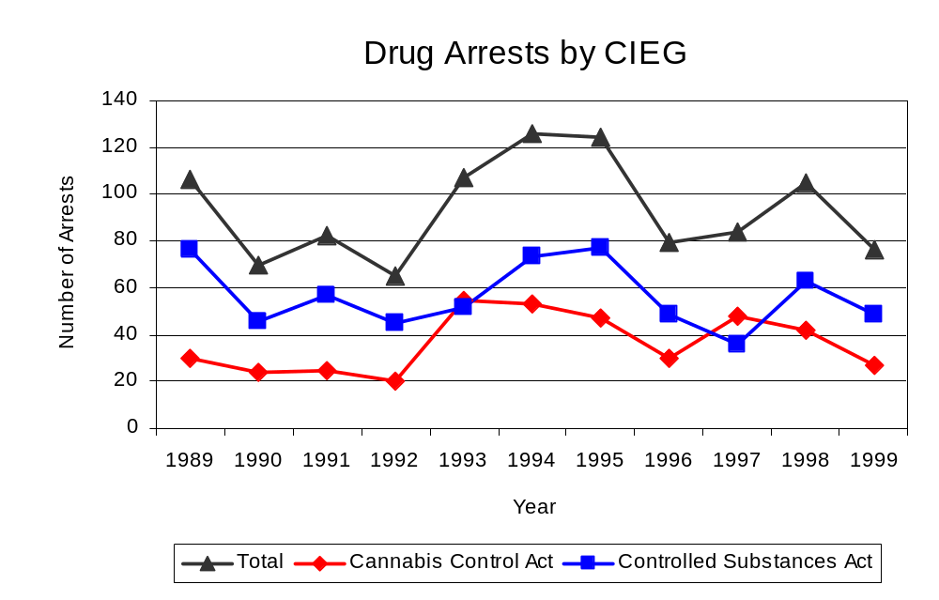
Source: CIEG
Figure 8
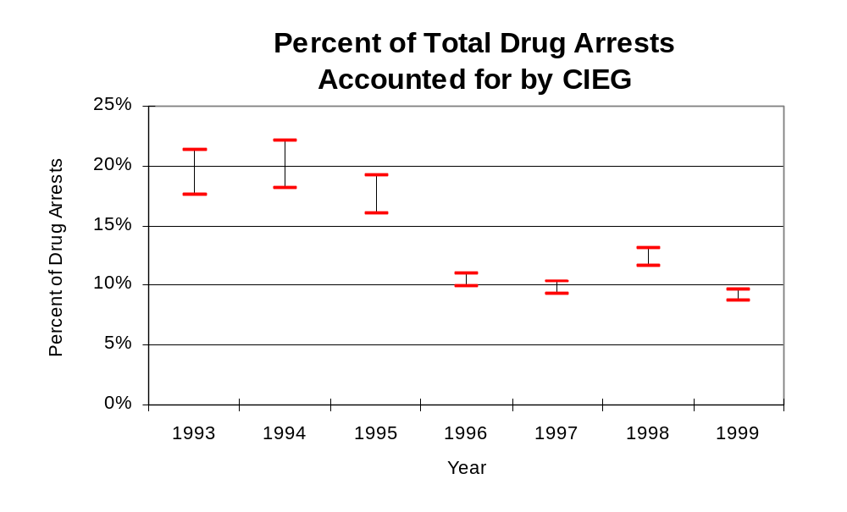
The data presented below represent the percent of total drug arrests made by agencies participating in CIEG accounted for by CIEG. An upper and lower bound is shown in Figure 9 which accounts for whether or not the units numbers are counted as part of the UCR submissions made by local departments (which is unknown at this point). The upper bound indicates the percentage of arrests if all of the CIEG arrests are included in the local UCR submissions. The lower bound indicates the percentage if none of the CIEG arrests are included in the local UCR submissions. It is estimated that the proportion of all drug arrests across participating agencies accounted for by CIEG was between 18 to 21 percent in 1993, but decreased to between 9 to 10 percent in 1999. Thus, despite the fact that the officers assigned to CIEG accounted for a small proportion of total officers in the region, they accounted for a relatively large proportion of the drug arrests in the region.
Figure 9
Source: ICJIA calculations using
Illinois State Police and CIEG data

The number of arrests for violations of Illinois’ Cannabis Control Act in Christian, Logan, Mason, Morgan and Sangamon counties totaled 764 in 1999, an 81 percent more than the 423 arrests made for cannabis violations in 1993. Between 1993 and 1999, the proportion of all drug arrests accounted for by violations of the Cannabis Control Act in the five-county region increased from 53 percent to 67 percent. Agencies participating in CIEG accounted for the largest portion (62 percent) of the total number of arrests for cannabis violations. CIEG reported a total of 27 arrests for cannabis violations in 1999, 36 percent of the unit's drug arrests.

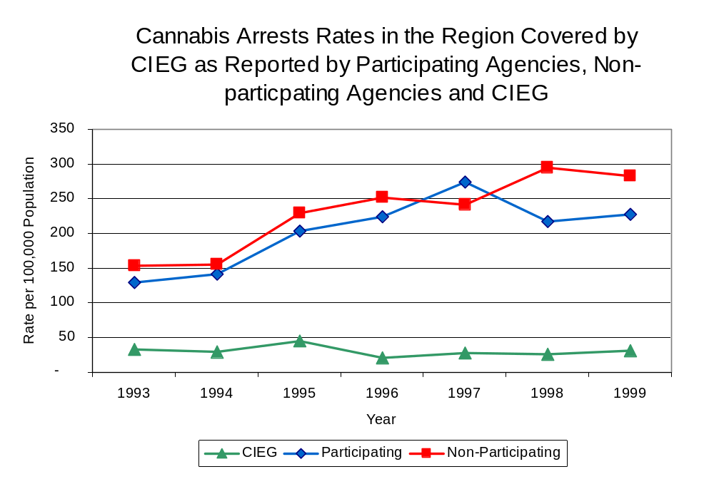
During the period analyzed, the cannabis arrest rate for the region covered by CIEG increased 79 percent, from 138 arrests per 100,000 population in 1993 to 246 arrests per 100,000 population in 1999. Similarly, the cannabis arrest rate in the participating agencies increased 76 percent, from 129 to 227 arrests per 100,000 population, while the arrest rate in the non-participating agencies increased 84 percent, from 153 to 283 arrests per 100,000 population. The cannabis arrest rate for CIEG, on the other hand, decreased 52 percent, from 27 to 13 arrests per 100,000 population (Figure 10). Thus, the arrest rate for violations of the Cannabis Control Act was collectively higher in the area served by participating agencies than in the combined jurisdictions of the non-participating agencies.
Source: ICJIA calculations using
Illinois State Police and CIEG data
Figure 10

The data presented in Figure 11 represent the percent of cannabis arrests made by the agencies participating in CIEG accounted for by CIEG. An upper and lower bound is shown which accounts for whether or not the unit’s numbers are counted as part of the UCR submissions made by local departments (which is unknown at this point). The upper bound indicates the percentage of arrests if all of the CIEG arrests are included in the local UCR submissions. The lower bound indicates the percentage if none of the CIEG arrests are included in the local UCR submissions. It is estimated that the proportion of cannabis arrests across participating agencies accounted for by CIEG was between 17 to 21 percent in 1993, but dropped to between 5 to 6 percent in 1999.

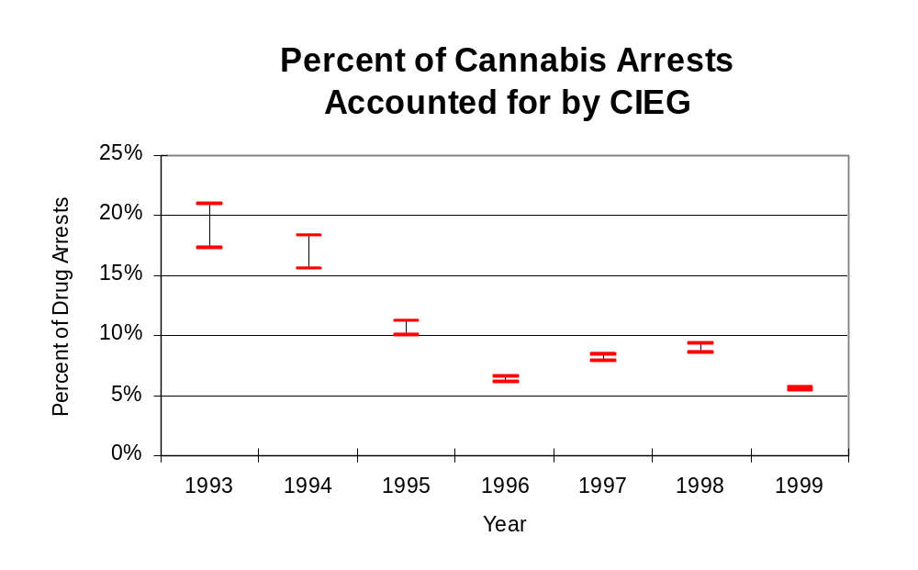
Figure 11
Source: ICJIA calculations using
Illinois State Police and CIEG data
In Christian, Logan, Mason, Morgan and Sangamon counties the number of arrests for violations of Illinois’ Controlled Substances Act decreased slightly between 1993 and 1999, from 371 to 369. Between 1993 and 1999, the proportion of all drug arrests accounted for by violations of the Controlled Substances Act in the five-county region decreased from 47 percent to 33 percent. In 1999, CIEG reported 49 arrests for controlled substance violations, 64 percent of all drug arrests reported to the Authority by the unit.

Between 1993 and 1999, the arrest rate for controlled substances act violations for the region covered by CIEG decreased 2 percent, from 121 to 119 arrests per 100,000 population (Figure 12). The controlled substances arrest rate in the participating agencies increased 31 percent, from 118 to 155 arrests per 100,000 population, while the arrest rate in the non-participating agencies decreased 63 percent, from 126 to 46 arrests per 100,000 population. The controlled substances arrest rate for CIEG decreased slightly from 26 to 24 arrests per 100,000 population (Figure 12). Thus, the Controlled Substances Act arrest rate was higher in the participating agencies than the non-participating agencies.

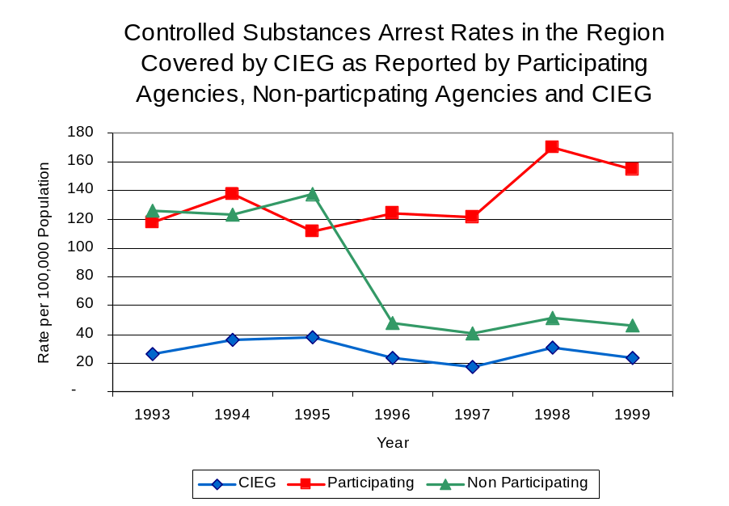
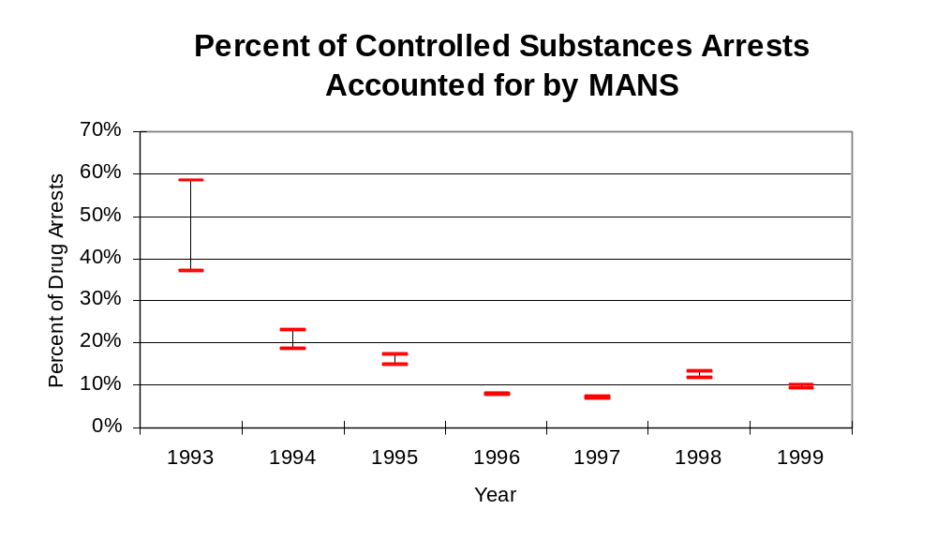
The data presented in Figure 13 represent the percent of controlled substances arrests made agencies participating in CIEG accounted for by CIEG. An upper and lower bound is shown which accounts for whether or not the units numbers are counted as part of the UCR submissions made by local departments (which is unknown at this point). The upper bound indicates the percentage of arrests if all of the CIEG arrests are included in the local UCR submissions. The lower bound indicates the percentage if none of the CIEG arrests are included in the local UCR submissions. It is estimated that the proportion of controlled substances arrests across participating agencies accounted for by CIEG was between 37 to 58 percent in 1993, but decreased slightly to between 9 to 10 percent in 1999.
Source: ICJIA calculations using Illinois State Police and CIEG data
Figure 12
Figure 13
Source: ICJIA calculations using
Illinois State Police and CIEG data

The majority (90 percent) of all drug arrests reported by CIEG are for delivery. Between 1993 and 1999, the number of drug delivery arrests made by CIEG decreased 19 percent, from 94 to 76. When cannabis and controlled substance arrests were examined separately, during the period analyzed, arrests for delivery of controlled substances accounted for 96 percent of the total number of arrests made for violations of the Controlled Substance Act, whereas, arrests for the delivery of cannabis accounted for 86 percent of all arrests for violations of the Cannabis Act.
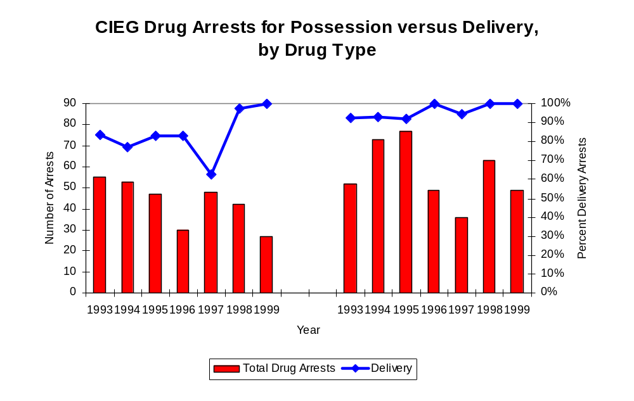
Figure 14
Source: ICJIA calculations using CIEG data
Cannabis Control Act
Controlled Substances Act

IV. Trends in Drug Seizures

Drugs seized by law enforcement agencies are another indicator of the extent and nature of illegal drug trade in a jurisdiction. When illegal drugs are seized by law enforcement agencies, all or a portion of the total amount seized is submitted to a crime lab for analysis. Most agencies submit drugs to one of the Illinois State Police crime labs. These labs record the quantity of drugs submitted from each county. This section discusses trends in the quantities of illegal drugs seized and submitted to the Illinois State Police from local law enforcement agencies in Christian, Logan, Mason, Morgan and Sangamon counties as well as the quantities of drugs seized by CIEG. It is important to note, however, that while CIEG data report the total quantities of drugs actually seized, local agency data only represent the quantities of seized drugs that are submitted to the Illinois State Police for analysis. County-level cannabis, cocaine and methamphetamine seizure rates for Illinois' 102 counties are provided in maps located in the Appendix of this report.

As in most Illinois jurisdictions, cannabis accounts for the majority of illegal drugs seized in the five-county region covered by CIEG. The quantity of cannabis seized and submitted by law enforcement agencies in Christian, Logan, Mason, Morgan and Sangamon counties more than doubled from 175,939 grams in 1993 to 393,894 grams in 1999. However, the quantity of cannabis seized by CIEG increased more than five-fold between 1993 and 1999, from 49,117 grams to 323,024 grams (Figure 15). In 1999, CIEG's cannabis seizure rate of 156,003 grams per 100,000 population was 23 percent higher than the seizure rate of 126,762 grams per 100,000 population in the five-county region covered by CIEG (Map 2).
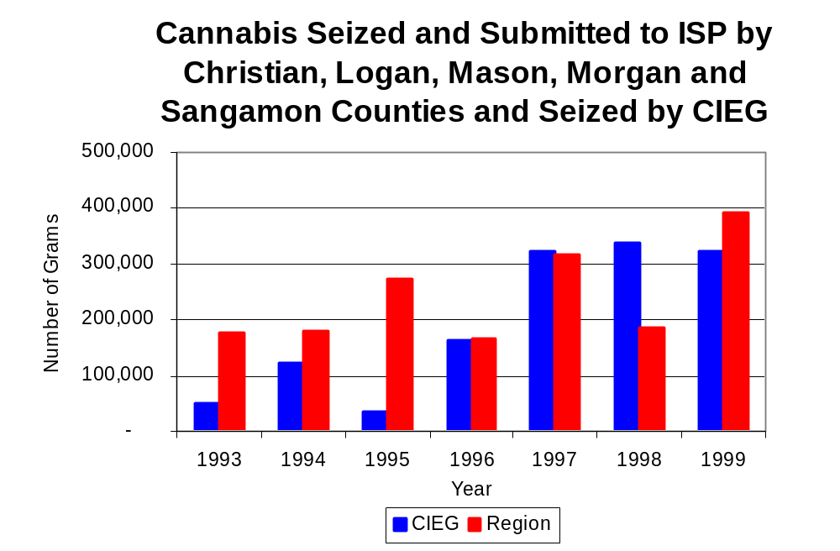
Figure 15
Source: Illinois State Police and CIEG
Between 1993 and 1999, a combination of crack and powder cocaine has accounted for a small proportion of drugs seized in the five-county region covered by CIEG. However, the quantity of cocaine seized and submitted by law enforcement agencies in Christian, Logan, Mason, Morgan and Sangamon counties increased 69 percent, from 1,555 grams in 1993 to 4,180 grams in 1999. Between 1993 and 1999, the quantity of cocaine seized by CIEG more than doubled, from 719 grams to 1,612 grams.

The proportion of all cocaine seized by CIEG accounted for by powder cocaine remained relatively stable between 1993 and 1999, whereas local seizures revealed a bit more variation. Consequently, in 1993, powder cocaine accounted for 52 percent of all cocaine seized in the five-county region covered by CIEG, compared to 57 percent in 1999. In contrast, for CIEG, although powder cocaine accounted for the largest proportion of total cocaine seizures during the period examined, the proportion accounted for by powder cocaine decreased from 77 percent in 1993 to 73 percent in 1999 (Figure 16). In 1999, CIEG's cocaine seizure rate of 356 grams per 100,000 population was 42 percent lower than the rate of 1,345 grams per 100,000 population in the five-county region covered by CIEG (Map 3).
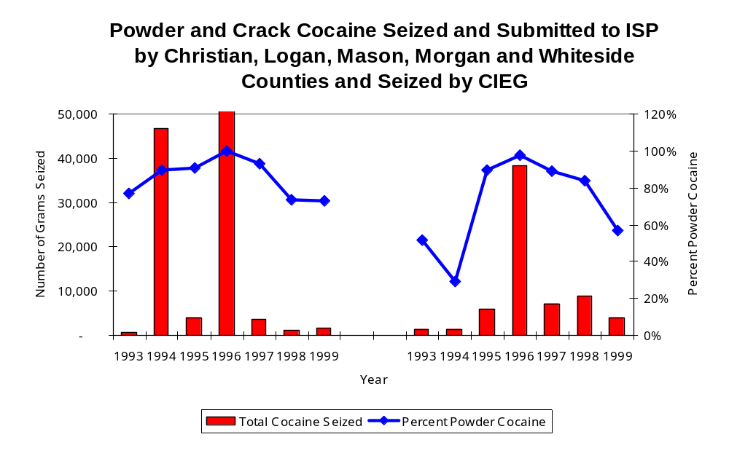
Figure 16
Source: Illinois State Police and CIEG
CIEG
Region
The total quantity of illegal drugs seized and submitted by law enforcement agencies in Christian, Logan, Mason, Morgan and Sangamon counties more than doubled between 1993 and 1999, from 177,587 grams to a period high of 398,646 grams. On the other hand, the total quantity of illegal drugs seized by CIEG increased more than five-fold, from 50,637 grams in 1993 to 324,692 grams in 1999.

During the period, methamphetamine seizures accounted for a relatively small proportion of total drugs seized by CIEG. Between 1993 and 1998, CIEG reported no methamphetamine seizures. However, in 1999, 56 grams of methamphetamine were seized by CIEG. Conversely, the quantity of methamphetamine seized and submitted by law enforcement agencies in Christian, Logan, Mason, Morgan and Sangamon counties more than tripled between 1993 and 1999, from 29 to 92 grams. In 1999, CIEG had a methamphetamine seizure rate of 27 grams per 100,000 population, slightly lower than the 29 grams per 100,000 grams per 100,000 population in the five-county region covered by CIEG and less than one-third the statewide seizure rate of 98 grams per 100,000 population (Map 4).

Trends in Prosecutions for Drug Offenses and All Felonies

Although Illinois has one of the best court reporting systems in the country, the Administrative Office of the Illinois Court only collects information regarding the aggregate number of court filings. Currently, there are no statewide data available on court filings by offense type. The Administrative Office of the Illinois Courts reports data on felony criminal court cases. After screening a case and deciding it warrants further action, the state’s attorney must file formal charges in court. Felony cases can be punished by a probation term up to four years and incarceration for more than one year.

Between 1989 and 1999, the number of felony filings in the five-county region covered by CIEG increased 85 percent, from 1,185 to 2,200 (Figure 17).

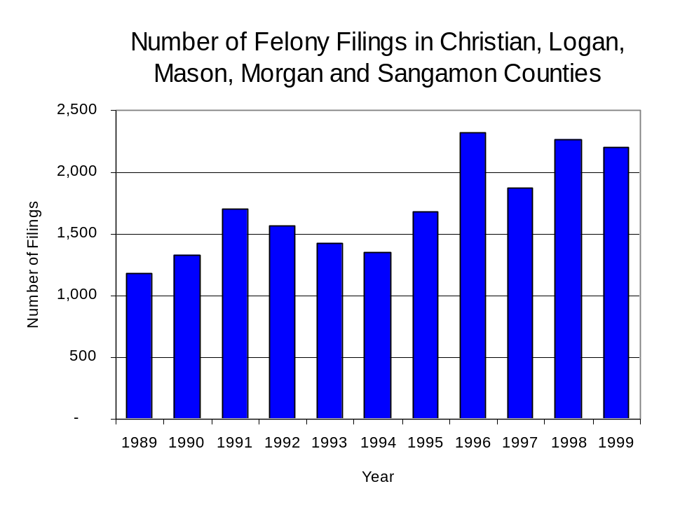
Figure 17
Source: Administrative Office of the Illinois Courts

Between 1989 and 1999, there were a total of 904 drug prosecutions initiated as a result of CIEG arrests in Christian, Logan, Mason, Morgan and Sangamon counties. During this time, the number of CIEG drug arrests decreased 28 percent, from 106 arrests in 1989 to 76 arrests in 1999 (Figure 18). Between 1991 and 1999, 94 percent of all drug arrests by CIEG resulted in a prosecution. The majority (63 percent) of CIEG drug offender prosecutions during this period were for violations of the Controlled Substance Act. In some years, the proportion of arrests resulting in a prosecution exceeded 100 percent. This is due to some slight differences in the timing of an arrest and the filings of charges, or could be due to charges, rather than defendants, being reported by the unit. In addition, some offenders have charges filed, and a subsequent warrant issued, without an arrest taking place.

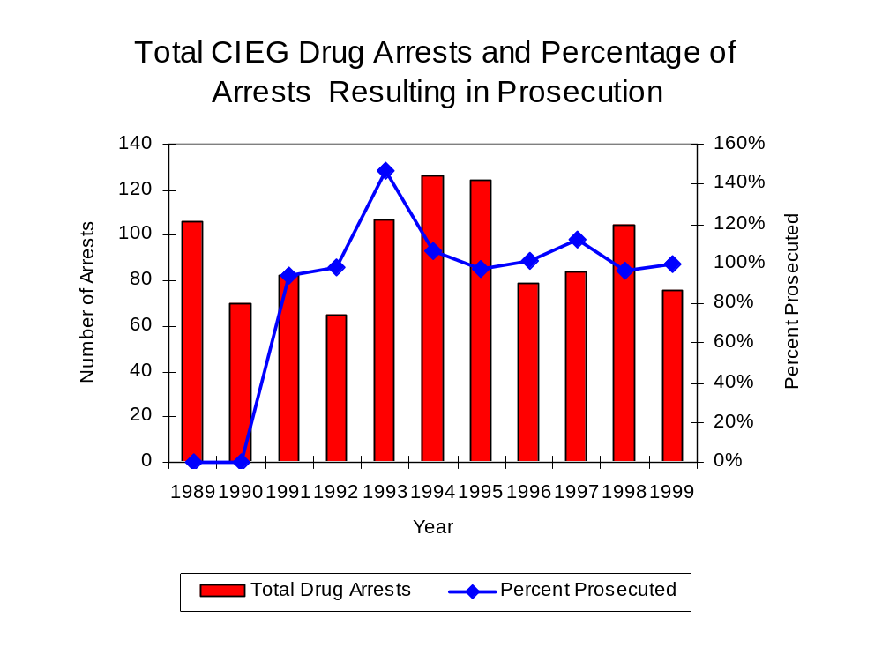
Figure 18
Source: CIEG

Between 1989 and 1999, the majority (799) of the 904 drug offenders who were prosecuted as a result of CIEG activity were convicted. Convictions for controlled substances accounted for 69 percent of all CIEG initiated convictions during the period analyzed.

VI. Trends in Percent of Convicted Drug Offenders Sentenced to Prison

Anyone convicted of a felony in Illinois can be sentenced either to prison or probation, or receive conditional discharge. A number of factors influence the type and length of sentence imposed on convicted felons, including the severity of the crime, the offender’s criminal and social history, safety of the community and legislation affecting certain types of offenses. For some types of convictions, a sentence to prison is required by state statute.

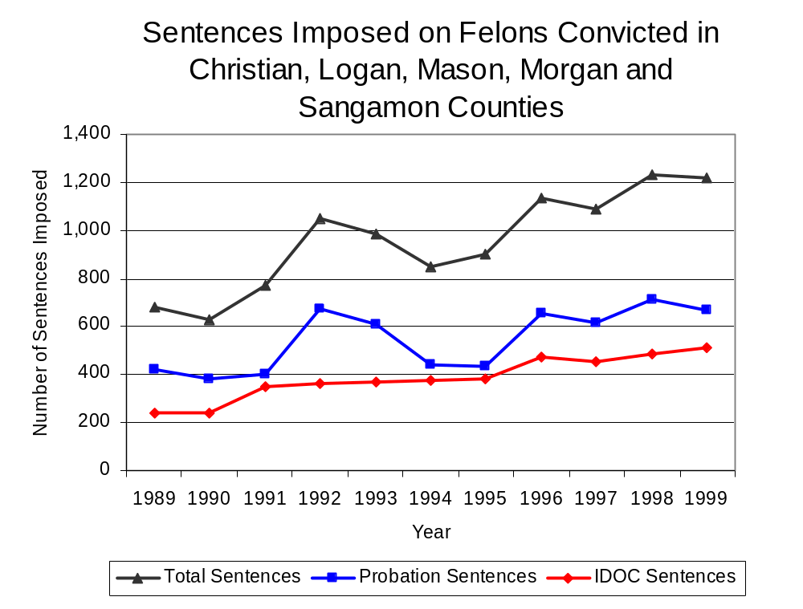
Between 1989 and 1999, the number of offenders convicted of a felony and sentenced in the five-county region covered by CIEG increased 79 percent, from 680 to 1,217. The number of convicted felons sentenced to the Illinois Department of Corrections (IDOC) more than doubled between 1989 and 1999, from 239 to 513. Consequently, the proportion of felons sentenced to IDOC increased during the same period, from 35 percent to 42 percent of total felony sentences. In 1999, 668 probation sentences were imposed on convicted felons, 59 percent more than the 421 probation sentences in 1989 (Figure 19). As a result, the proportion of felons sentenced to probation decreased from 62 percent in 1989 to 55 percent in 1999. Sentences other than prison or probation account for the remaining 3 percent of felony sentences imposed in 1999.
Figure 19
Source: Administrative Office of the Illinois Courts

Between 1989 and 1999, the number of CIEG drug offenders convicted and sentenced increased from zero to 39. During the period analyzed, the number of convicted CIEG drug offenders sentenced to prison increased from zero in 1989 to 16 in 1999, while both probation and jail sentences increased from zero in 1989 to 16 and seven, respectively, in 1999 (Figure 20). In 1999, among those CIEG drug offenders convicted and sentenced, prison and probation sentences each accounted for 41 percent of total sentences, while jail sentences accounted for 18 percent of drug offenders convicted and sentenced.
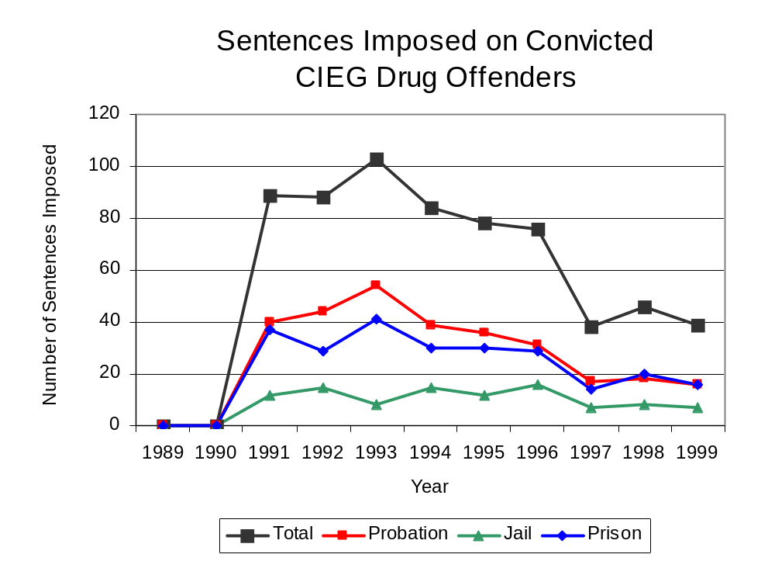
Figure 20
Source: CIEG

Between state fiscal years 1989 and 1999, the number of new court commitments to IDOC’s Adult Division for drug offenses from the five-county region covered by CIEG more than tripled, from 23 to 81. The number of drug offender admissions by CIEG also increased from zero to 15 between 1989 and 1999 (Figure 21). Thus, during the period analyzed, prison sentences resulting from CIEG cases accounted for one-third of all drug-law violators sentenced to prison from the region where CIEG operates.

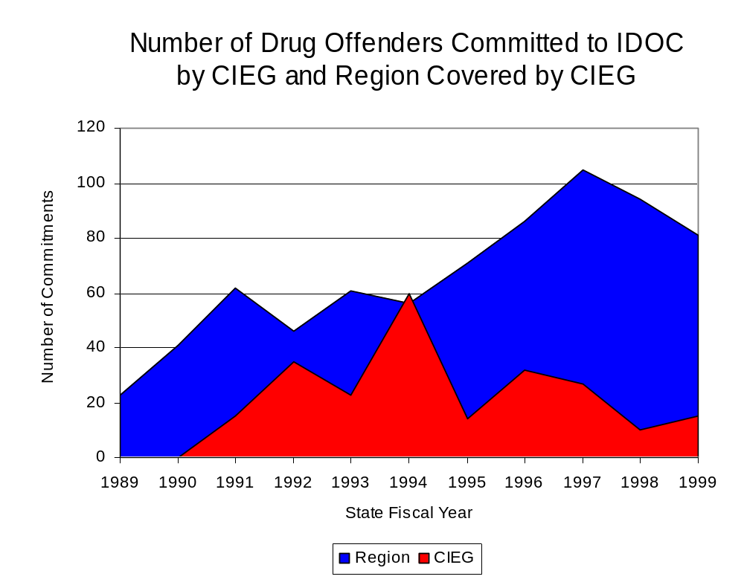
Figure 21
Source: Illinois Department of Corrections and CIEG

During the period analyzed, drug offenders accounted for an increasing proportion of adults convicted and sentenced to prison from Christian, Logan, Mason, Morgan and Sangamon counties. In 1989, drug offenses accounted for 10 percent of all commitments to IDOC, compared to 19 percent in 1999 (Figure 22).
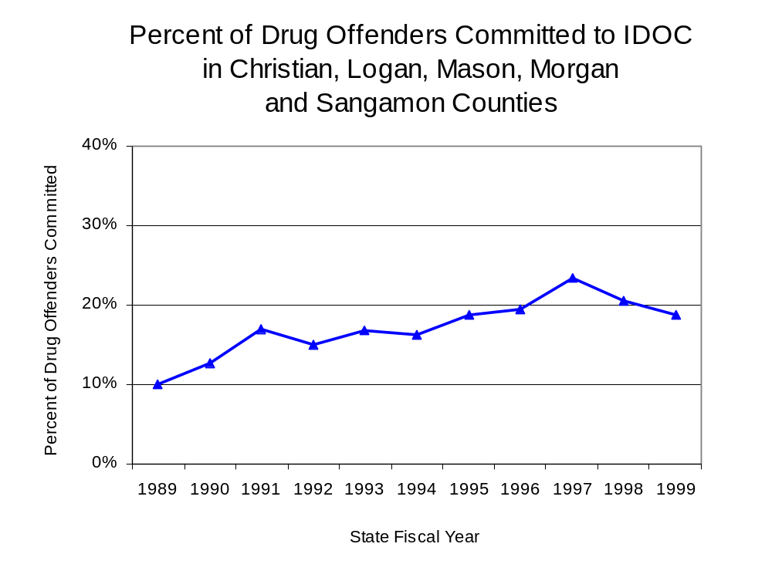
Figure 22
Source: Illinois Department of Corrections

Penalties for drug offenses were also examined between 1993 and 1999. Class 4 felonies accounted for the largest proportion (50 percent) of sentences to IDOC for drug offenses, followed by Class 2 felonies (21 percent), Class 1 felonies (16 percent), Class 3 felonies (10 percent) and Class X felonies (4 percent). Between 1993 and 1999, the number of Class 4 felony sentences increased 63 percent, from 27 to 44, while Class 2 felony sentences more than tripled, from four to 13 and Class 1 felony sentences more than doubled, from five to 12. The number of Class 3 and Class X felonies increased slightly, from seven to nine and from one to three, respectively (Figure 23).

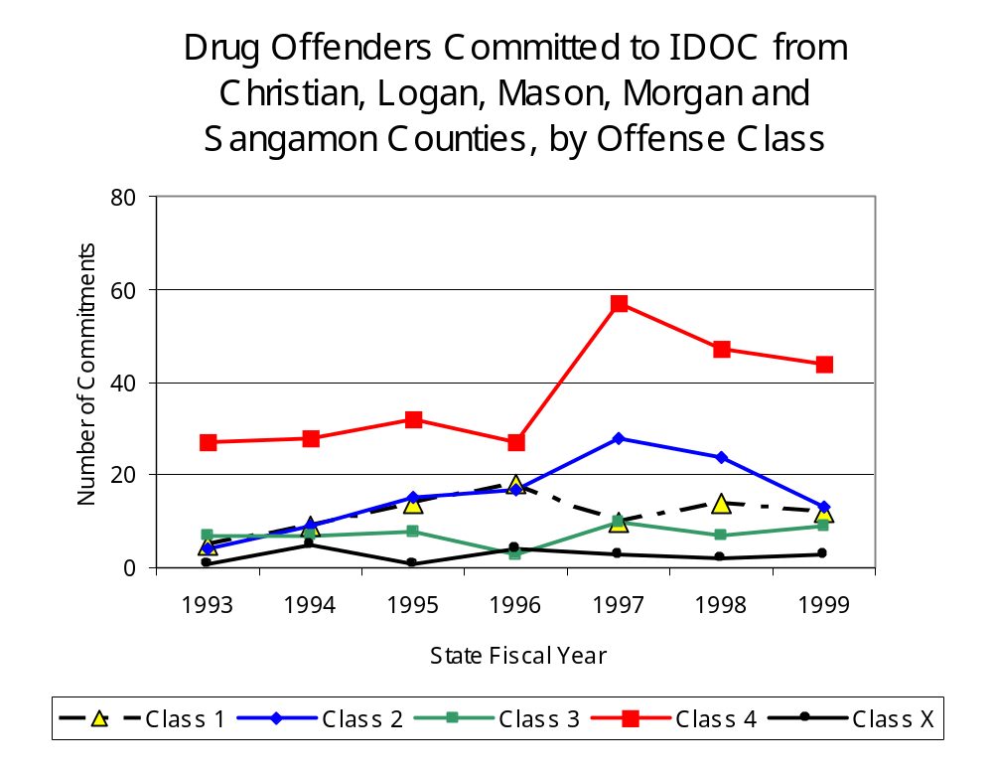
Figure 23
Source: Illinois Department of Corrections

Between 1993 and 1999, the mean sentence length for Class 4 and Class 2 felonies increased only slightly, from 1.9 to 2.1 years and from 3.8 to 3.9 years, respectively, during the period, while the mean sentence length for Class 1 felonies increased 83 percent, from three to 5.5 years. Conversely, the mean sentence for a Class 3 felony decreased 12 percent, from 3.3 to 2.9 years, and Class X sentence lengths decreased from 20 to ten years.

VII. Trends in Drug Treatment Admissions in CIEG Region by Drug Type

In addition to considering indicators of the extent and nature of drug abuse as reported through the criminal justice system (for example, arrests and prison sentences), there are indicators of substance abuse available from other Illinois social service agencies. Overseeing and supporting treatment for substance users, whether they are referred from the criminal justice system or elsewhere, is the responsibility of the Illinois Department of Human Services’ Office of Alcoholism and Substance Abuse (OASA). It is important to note, however, that while OASA data represent the majority of the overall demand for substance abuse treatment in the state, some private programs provide treatment services to a smaller but significant number of clients who may not be included in the state’s reporting system.

In state fiscal year 1999, OASA reported 3,729 admissions for alcohol or drug abuse treatment from Christian, Logan, Mason, Morgan and Sangamon counties, more than double the 1,703 admissions in 1989 (Figure 24). Among the 3,729 admissions to substance abuse treatment in state fiscal year 1999, 47 percent (1,755) reported alcohol as their primary substance of abuse, while abuse of illicit substances accounted for one-half and 2 percent reported no primary substance of abuse.

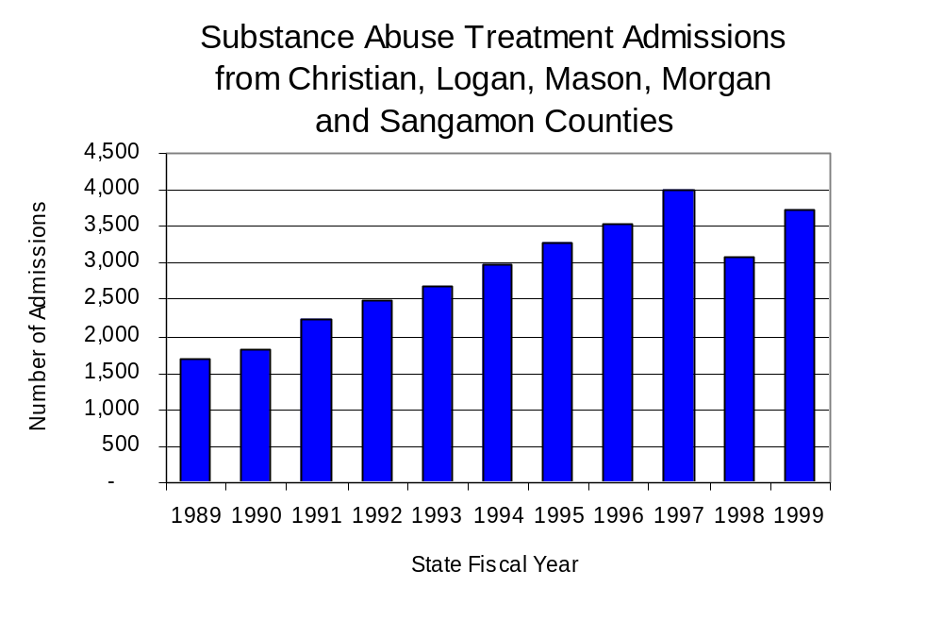
Figure 24
Source: Illinois Department of Human Services’
Office of Alcoholism and Substance Abuse
While drug treatment admissions can be considered a measure of the demand placed on a specific component of the human services system within Illinois, the extent and nature of drug treatment admissions could also be indicative of the substance abuse problem within a particular region. In some respects, the characteristics of those admitted to drug treatment can be considered a profile of the most serious drug abusers in the community, since admission to treatment requires a documented, formal assessment of a drug problem and a level of substance abuse warranting treatment. By comparing the types of drugs of abuse reported by those admitted to substance abuse treatment with the types of drugs involved in law enforcement agency arrests, one can get a sense of the degree to which arrests reflect the drugs which are most problematic within a community.

In the following analyses, the percent of arrests accounted for by drugs classified under Illinois’ Controlled Substances Act (primarily cocaine, heroin, and methamphetamine) versus the Cannabis Control Act (marijuana) across the participating agencies combined, non-participating agencies combined and CIEG are compared to the proportion of drug treatment admissions accounted for by these groups of substances. From these comparisons, a number of general conclusions can be made. First, the proportion of arrests made by CIEG accounted for by drugs other than marijuana (Controlled Substances Act offenses) was very close to the proportion of drug treatment admissions from the covered region accounted for by these substances. Thus, there is considerable convergence between the drugs involved in CIEG arrests and treatment admissions. On the other hand, the majority of arrests by local police departments (including those participating in CIEG and non-participating agencies) were for cannabis offenses. Thus, while local arrests may reflect the most widely available and used drug in the region, they tend not to involve the substances considered to be most serious (i.e., felony versus misdemeanor) nor the substances individuals are seeking and receiving treatment for (Figure 25).

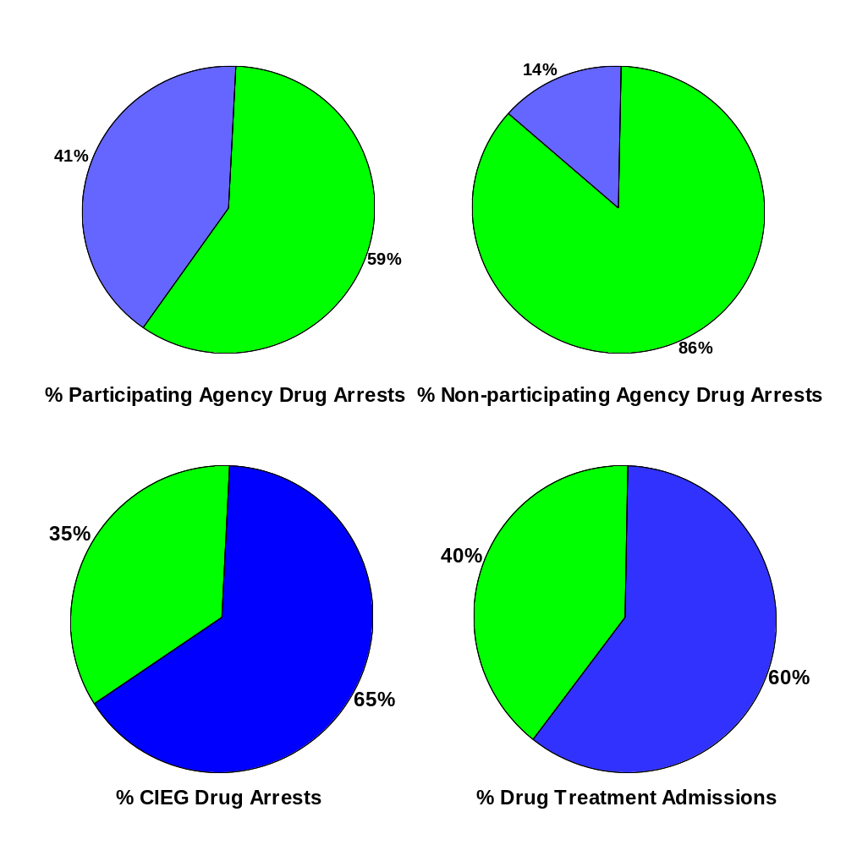
CannabisControlled Substances
Comparison of Drug Arrests by CIEG and Participating and
Non-participating Agencies vs. Drug Abuse Treatment Admissions in Christian, Logan, Mason, Morgan and Sangamon Counties, 1999
Source: ICJIA calculations using Illinois Department of Human Service's Office of Alcoholism and Substance Abuse and CIEG data
Figure 25

VIII. Trends in Drug Exposed Births

Illinois continues to experience the effects of prenatal substance abuse. In Illinois, if a baby is born and thought to have been exposed to illegal substances or alcohol, either through observation by physicians or toxicology tests, the case is reported to the Illinois Department of Children and Family Services. These cases are then investigated by DCFS to verify the child’s prenatal exposure to either alcohol or illegal substances. Between state fiscal years 1989 and 1999, nearly one-half (50) of Illinois’ 102 counties reported at least one case of a substance-affected infant.

Between state fiscal years 1989 and 1999, the number of drug-exposed infant cases reported in the five-county region covered by CIEG increased 58 percent, from 12 to 19. However, the number of drug-exposed infant cases more than tripled between 1991and 1993, jumping from 12 to a period high of 40, before decreasing to lower, relatively stable trends. Between state fiscal years 1989 and 1999, 189 cases, or 78 percent of all cases reported, were verified as involving prenatal drug use by a DCFS investigation. Mirroring the trend of reported cases, verified cases of drug-exposed infants in the CIEG region also jumped dramatically between 1991 and 1993 from eight to 36 before leveling off in 1996. During the period analyzed, the number of verified cases of drug-exposed infants increased 44 percent, from nine in 1989 to 13 in 1999 (Figure 26).
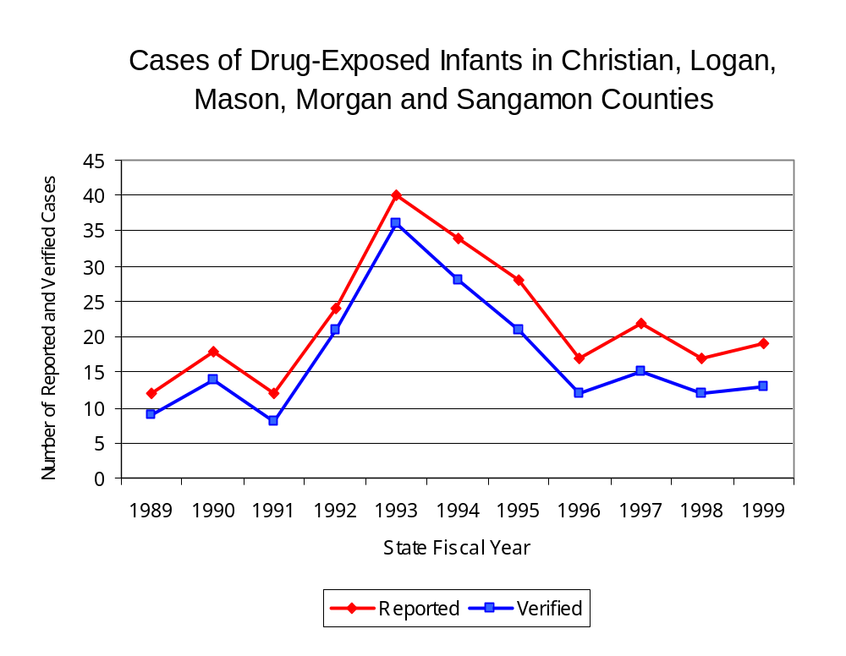
Source: Department of Children and Family Services
Figure 26

Summary of Drug Situation

Although the distribution of illegal drugs is difficult to measure precisely, data obtained from criminal justice sources can be helpful in estimating drug availability. Information from a recent survey of Illinois drug enforcement units, as well as the most up-to-date data available on drug price, are presented as indicators of the drug supply in Illinois.

In 1995, 1996 and 1998, the Authority conducted a survey of each MEG and task force in Illinois to gauge the perceived availability of drugs in the areas they cover. Questions were asked concerning the availability of specific drugs, and results were analyzed by region of the state. MEGs and task forces are classified as being either urban, rural or mixed urban/rural based upon the classification of the county(s) that each unit covers, and, for purposes of this report, are compared to the average of similar units.

According to CIEG survey responses, cannabis, cocaine and crack continued to be the most visible drugs on the street and were all reported to be “readily available” across all regions analyzed. LSD has decreased slightly in all regions since the 1996 survey, while all other drug types increased slightly across all MEGs and task forces in mixed urban/rural regions similar to CIEG, while the perceived availability of all other drug types remained unchanged in the five-county region covered by CIEG. The perceived availability of those same drug types, with the exception of cocaine, has increased across Illinois since the 1996 survey. Methamphetamine was reported as moderately available across Illinois but available to a somewhat greater degree in the region covered by CIEG. On the other hand, LSD and PCP appear to be less readily available in the five-county region covered by CIEG than across the state and all other MEGs and task forces in mixed urban/rural regions (Figure 27).
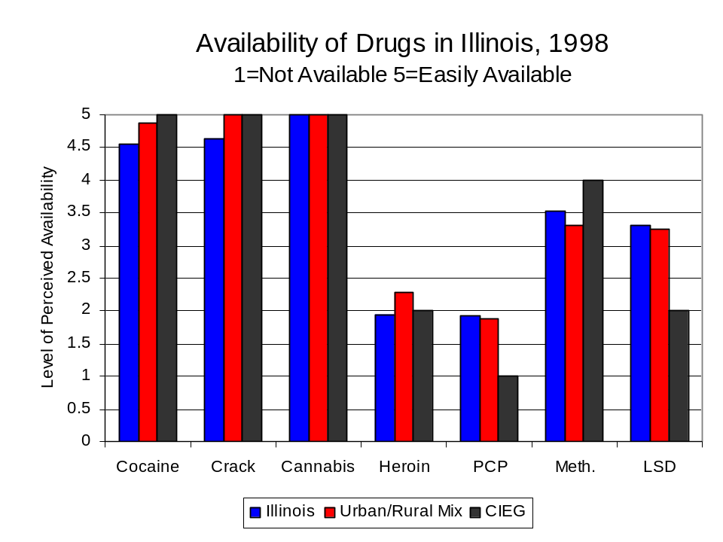
Figure 27
Source: Authority Survey of Illinois MEGs and task forces
Another market indicator that can be used to assess availability is drug price. Lower prices tend to suggest a sufficient supply to meet demand, while increasing prices indicate decreased availability.

Based on a statewide survey of MEG and task force units, the average price of crack, cannabis and methamphetamine appear to be relatively stable across all regions surveyed in 1998, while prices for cocaine, PCP and heroin appear to vary somewhat across Illinois. The average price of crack decreased in all regions, while the average price of cocaine increased across all regions analyzed. The 1998 average price of cocaine reported by CIEG was $125 per gram, compared to $98 per gram across Illinois and $103 per gram reported by all MEGs and task forces in other mixed urban/rural regions (Figure 28). On the other hand, the average price of heroin in the region covered by CIEG was reported as $325 per gram (more than triple the price reported in the 1996 survey), significantly higher than the price of $165 per gram across Illinois and the price of $214 per gram reported by all other MEGs and task forces in mixed urban/rural regions. In 1998, the average price of cannabis was reported as approximately $10 per gram in the CIEG region, $6 per gram in primarily mixed urban/rural regions and $8 per gram across Illinois.

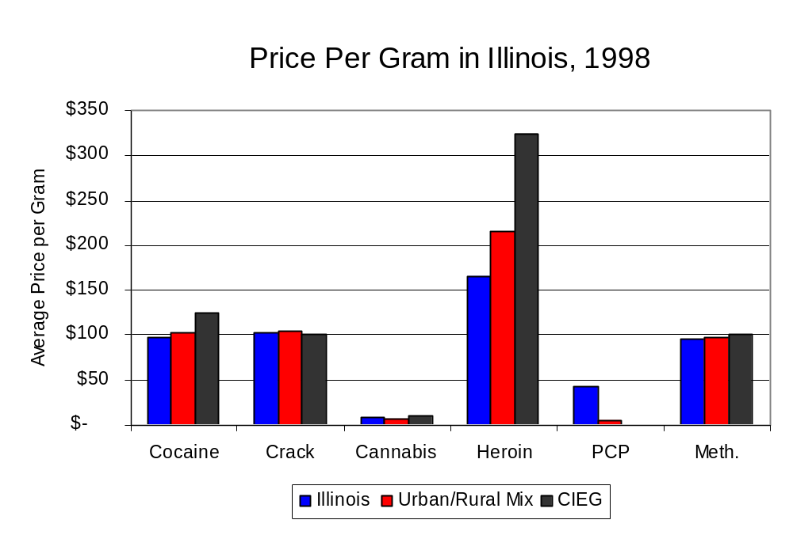
Figure 28
Source: Authority Survey of Illinois MEGs and task forces

X. Appendices
1999 Percent of Illinois'
County-level Population Covered by an Authority-funded Multi-jurisdictional Enforcement Group or Task Force
Map 1
* Shaded counties indicate that at least one law enforcement agency within the county participates in a MEG or task force
Percent of County Population Covered by MEG or Task Force

1999 Illinois
Cannabis
Seizure Rates, by County
Map 2
Cannabis Seizure Rate
(rate per 100,000 population)
1999 Illinois
Cocaine
Seizure Rates, by County
Map 3
Cocaine Seizure Rate
(rate per 100,000 population)
1999 Illinois Methamphetamine
Seizure Rates, by County
Map 4
Methamphetamine Seizure Rate
(rate per 100,000 population)

Bibliography

Administrative Office of the Illinois Courts, Annual Report to the Supreme Court of Illinois.
1989 through 1999 reports, Springfield, Illinois.

Administrative Office of the Illinois Courts’ Probation Division, Statewide Probation Data
Report. 1989 through 1999 reports, Springfield, Illinois.

Illinois Department of Human Services’ Office of Alcoholism and Substance Abuse. Data
provided for state fiscal years 1989 through 1999, Springfield, Illinois.

Illinois Department of Children and Family Services, Child Abuse/Neglect Statistics Report,
1989 through 1999 reports, Springfield, Illinois.

Illinois Department of Corrections. Data provided for fiscal years 1989 through 1999,
Springfield, Illinois.

Illinois State Police, Crime in Illinois. 1993 through 1999 reports, Springfield, Illinois.

Illinois State Police, Drug Statistics Report. Monthly reports, January 1989 through
December 1999, Springfield, Illinois.

Central Illinois Enforcement Group. Monthly reports, January 1989 through December
1999, Springfield, Illinois.

U.S. Bureau of the Census.


George H. Ryan, Governor
Peter B. Bensinger, Chairman
Candice M. Kane, Executive Director

